NAME:JAYAHARINI.J

REG NO :192371034

CLASS EXERCISE-UNIT-II

1)Create an HTML form to input 3 subject marks. Use JavaScript to:

Calculate the average (use arithmetic operators)

Display grade using ternary operators:

o A: ≥ 90

o B: 75–89

o C: 50–74

o F: &lt; 50

Also check if the student failed in any subject using logical operators.

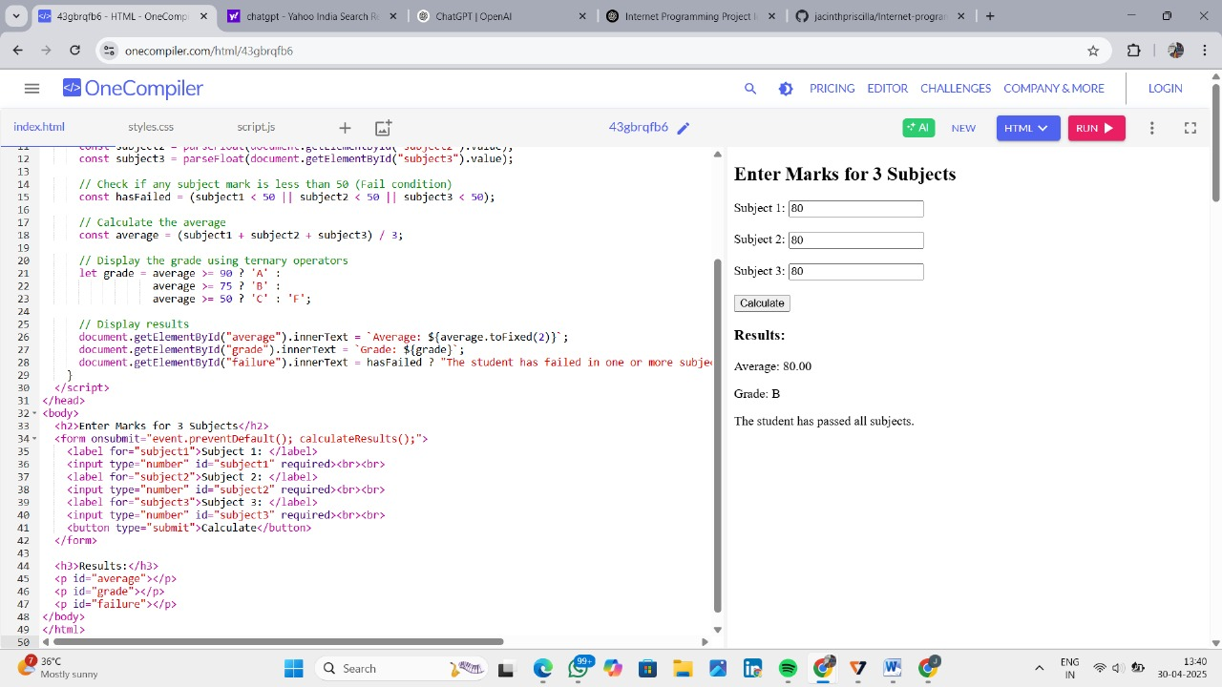

2)Design a calculator interface with:

Two inputs and buttons for: +, -, \*, /, %, \*\*

Show the result in a &lt;div&gt;

Use switch-case or if-else to handle different operations

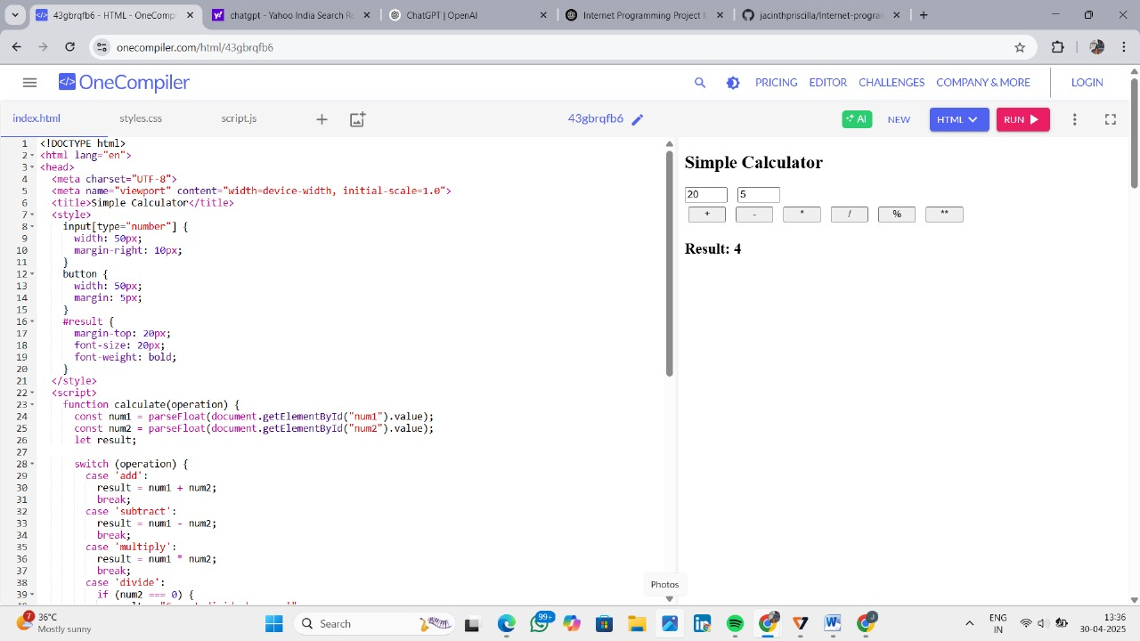

3. Create an HTML form that accepts name and email from the user, and on submit, convert the data

into a JSON string and display it.